**AVC plan – “Barbie 2016”**

https://github.com/j-salvador/barbie2016

James Magallanes - Networking

Jesse Wood – Team Management

Calvin Rowe – Software Development

Suraj Sathish – Software Development

Patrick Coulson – Hardware Design

Vincent McQueen – Hardware Design

**Potentially conflicting items**

30th, 31st May – Holiday (Vincent)

3rd, 4th, 5th May – Design projects (Patrick & Vincent)

14th June – ENGR121 Exam (James, Jesse, Calvin, Suraj)

23rd June – COMP102 Exam (James, Jesse, Calvin, Suraj)

**Team Agreement**

By signing below, all team members are acknowledging that they have read and

committed to their part in the AVC. They acknowledge that they will attempt

to complete the tasks agreed on by the group each week and document this on

the team github account. They acknowledge that failure to meet these goals

can result in the team recommending any member receives a lesser grade for

their AVC report. In the event that a team member is unable to complete their

task due to circumstances beyond their control (i.e. sickness, bereavement etc.)

that they will inform the team at the earliest possible time. Finally, the team

acknowledges that a member going a week without contact with other team

members (except when discussed with the team in advance) will constitute the

member in question being considered AWOL. In this instance the team agrees

to inform the ENGR101 course co-ordinator immediately. The penalty this for

this can range from a reduction in the final grade to immediate failure of the

AVC (and thus the ENGR101 course). Should the team unanimously agree that

a member (or members) have failed to contribute to the AVC sufficiently for

other reasons, on the day of robot testing the team will be given the opportunity

to anonymously vote for a team member to receive 0% for the robot part of the

AVC. Should the team choose this option they MUST be able to show that the

member in question had been assigned tasks that they failed to complete and

that the team had afforded them an opportunity to make up for past mistakes.

Signed by all team members:

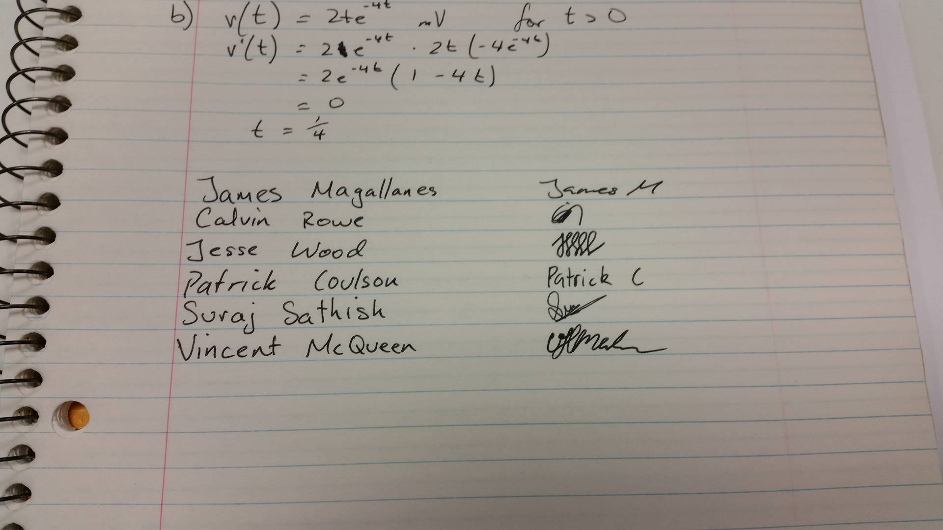

|  |  |  |  |  |  |
| --- | --- | --- | --- | --- | --- |
| Week | Dates | Team Objectives | Items Due | Conflicts | Tasks |
| 1 | 18/04/2016 | -Move forward  -Basic design | AVC plan due | Jesse/Calvin/Suraj: PHYS122 Test | Jesse: Arrange team meetings  Suraj/Kelvin: Write code for straight line movement  James: Set up git repository  Vincent/Patrick: Basic design |
| 2 | 25/04/2016 | Quadrant 1 |  | Vincent: Away for weekend | ALL: Write background section  Jesse: Arrange online meeting + Gantt charts  Vincent/Patrick: Continue design  Suraj/Calvin: Upload code  James: Update GitHub with progress, start networking |
| 3 | 02/05/2016 |  |  | Vincent/Patrick: Design projects | ALL: Write methods section  Jesse: Update Gantt chart  Suraj/Calvin: Test code  Vincent/Patrick: Prototype design  James: Test networking code |
| 4 | 09/05/2016 | Quadrant 2 |  |  | ALL: Write results and discussion section  Suraj/Calvin: Summarise code ideas for Quadrant 2  Patrick/Vincent: Possible design changes |
| 5 | 16/05/2016 | Quadrant 3 | Progress Report |  | ALL: Update previous sections  Suraj/Calvin: Summarise code ideas for Quadrant 3  ALL: Understand the coding and hardware/design decisions so far |
| 6 | 23/05/2016 |  |  |  | ALL: Revise report based on feedback from progress report |
| 7 | 30/05/2016 | Quadrant 4 |  |  | ALL: Update previous sections  Suraj/Calvin: Summarise code ideas for Quadrant 4  Vincent/Patrick: Final design tweaks  ALL: Retest older quadrants |
| 8 | 06/06/2016 | Finish Report |  |  | ALL: Write conclusion and abstract section  Jesse: Finish Gantt chart  ALL: Spelling and grammar check |
| 9 | 13/06/2016 |  | Report Due |  | James: Finalise GitHub  Suraj/Calvin: Review documentation |